Master Says


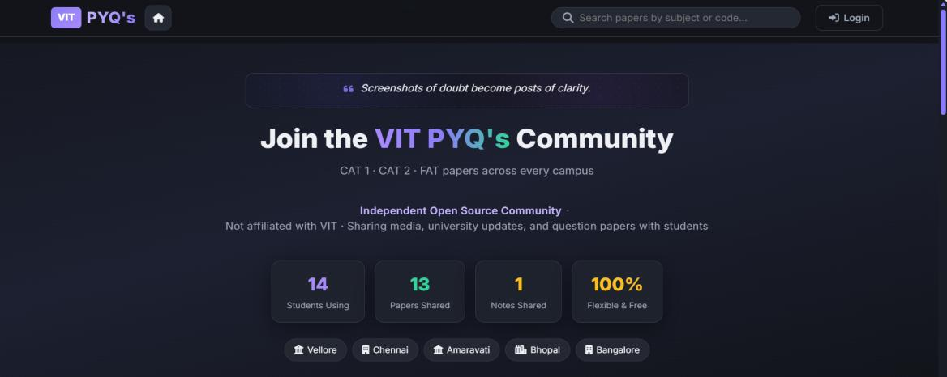
Sound familiar?
Every VIT student has been here. The good news: There is one place that solves all of it.
Can't find previous year question papers before CAT or FAT?  VIT PYQ's fix: Filter by exam, semester and year, then download for free. | Chasing seniors and group chats for notes?  VIT PYQ's fix: Download notes shared by students from all five campuses.
Wondering what your GPA or CGPA could turn out to be?  VIT PYQ's fix: Enter credits and expected grades for an instant estimate. | Struggling with slot clashes while planning your timetable?  VIT PYQ's fix: The planner rejects clashing slots automatically.
Want to help your juniors and get rewarded for it?  VIT PYQ's fix: Upload a paper, earn ZX and climb the leaderboard. | Worried about your privacy online?  VIT PYQ's fix: Choose a public or private profile. No ads, no tracking cookies.

Meet VIT PYQ's: a free, community-driven platform where VIT students share previous year papers and notes, and use handy tools, all in one place.

1. Website Overview
 | Website name | VIT PYQ's: For VITians
 | Website URL | https://vit-pyq-v2.web.app
 | Main purpose | Helps VIT students find and share previous year question papers (CAT 1, CAT 2, FAT) and study notes, with tools for GPA and timetable planning.
 | Target audience | VIT students on all five campuses: Vellore, Chennai, AP, Bhopal and Bangalore.
 | Cost | Free to use. Downloads are free, and every logged-in user gets a free subscription with lifetime access.

2. Main Pages & Structure
Everything is reachable from the top menu (or the bottom bar on mobile)

Home | Welcome page with community stats, campus list, quick paper filters and the Student Tools (GPA predictor, timetable planner), plus student feedback.
Media | Browse question papers and notes. Filter by exam (CAT 1 / CAT 2 / FAT), semester (Fall / Winter) and year.
Upload | Share a question paper or study notes, preview before submitting and earn ZX rewards.
Store | Spend ZX on badges, profile designs and a Verified tick.
Leaderboard | Highlights top contributors: most uploads, most ZX and most downloads.
Global Chat | Chat with the community, request papers, add friends and message privately.
My Profile | Your stats, subscription plan, Vault, bookmarks, liked papers and privacy settings.
Developer | About the student who built the platform.

3. What You Can Do
Features explained simply
Login
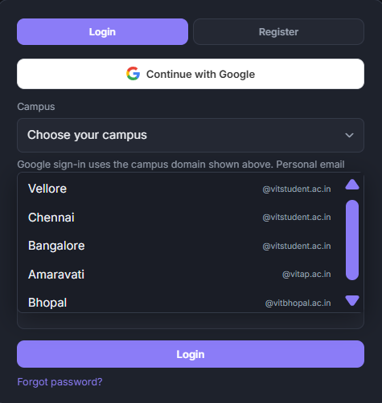 | 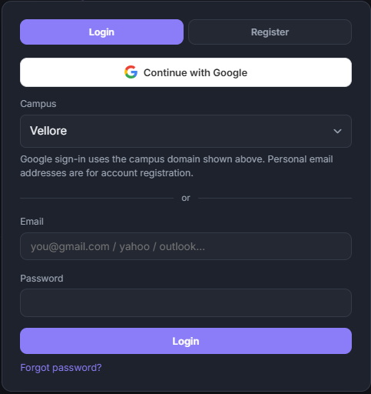

Community Terms
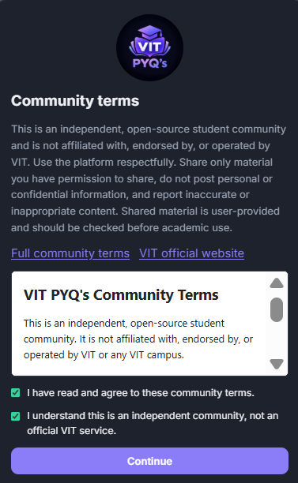
Question Papers: find what you need in seconds
Pick the exam type, semester and year and the matching papers appear. Open a paper, view it, rate it, bookmark it, like it or download it. All free. Papers cover every campus, so you are never limited to your own.
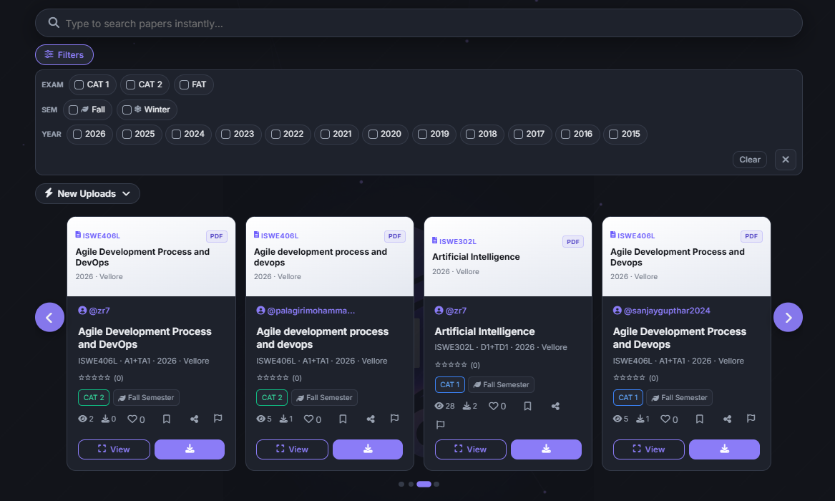

Study Notes: learn from your fellow students
Students from different campuses share notes by subject, year and semester. Need something that is missing? Ask in Global Chat and someone may upload it for you.
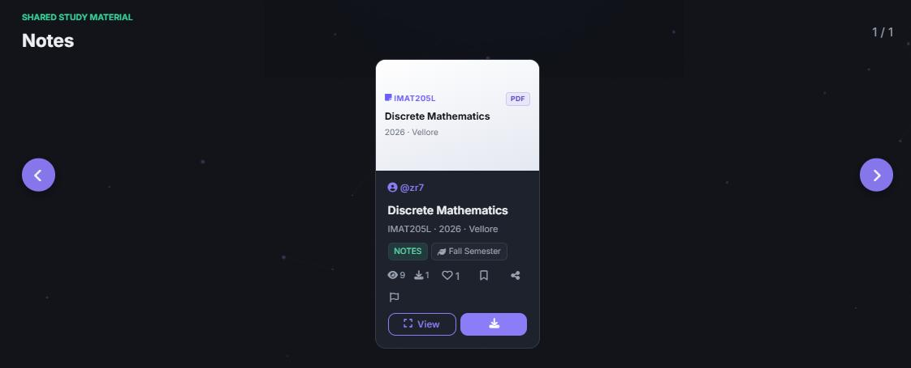
Student Tools:
GPA & CGPA Predictor: plan your results
VIT grades are relative, so the predictor works from what you expect. Add each subject with its credits and expected grade for a semester GPA, or enter each semester's GPA and credits for your CGPA. Export or print the result.
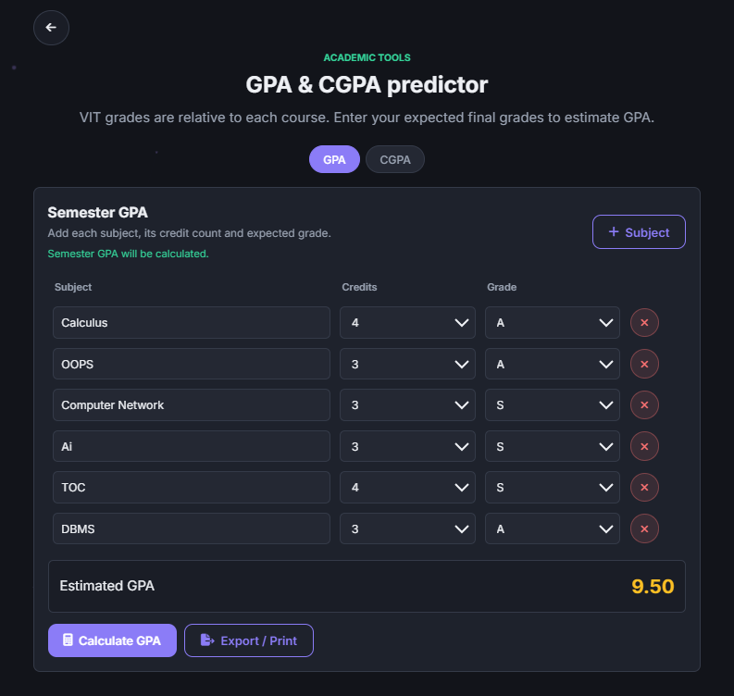

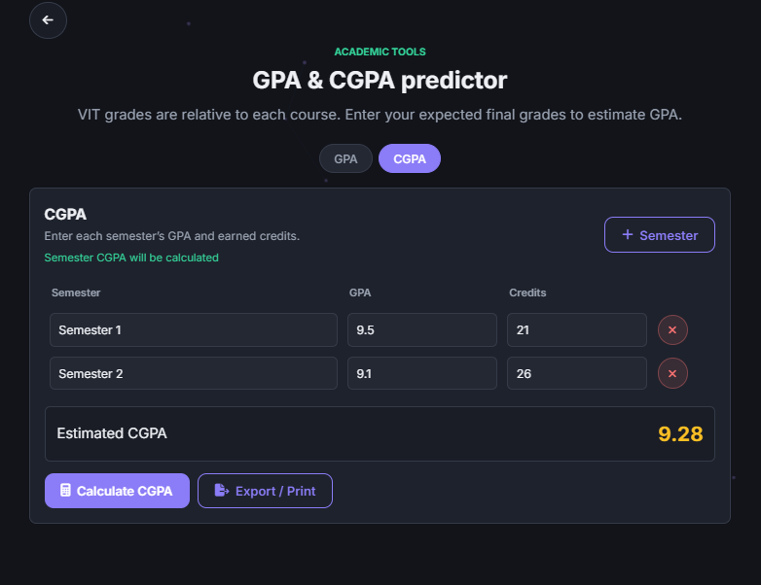
Timetable Planner: no more slot confusion
Choose theory or lab slots (A1, B1, C1 and so on) and the weekly grid fills automatically using VIT slot timings. If two slots clash, the planner rejects the combination. Name your timetable and export it to Excel or PDF.
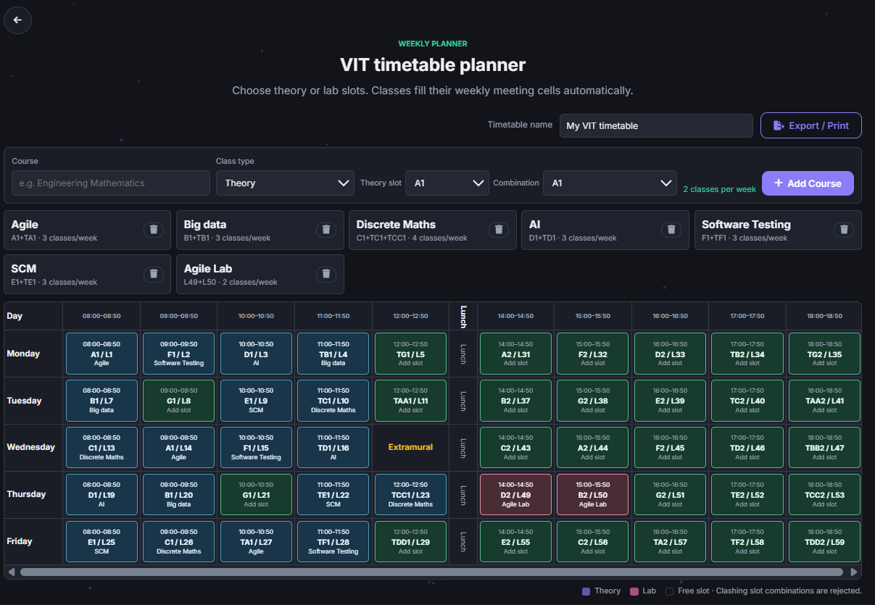

Exported Visual
GPA  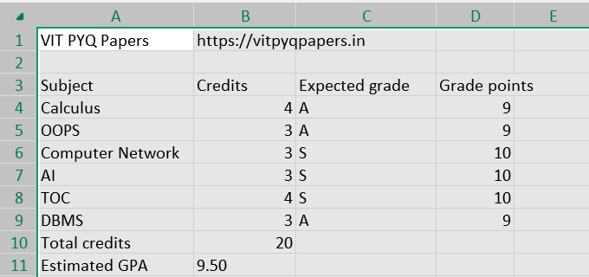  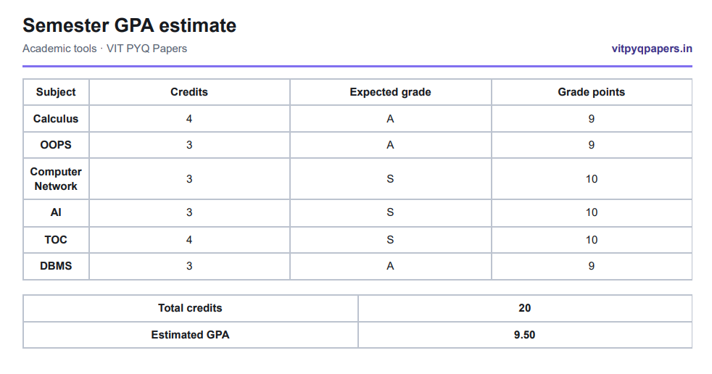 | CGPA  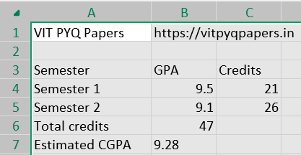  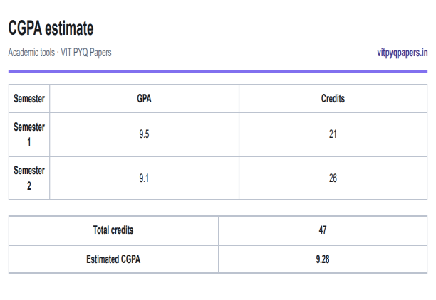
Timetable
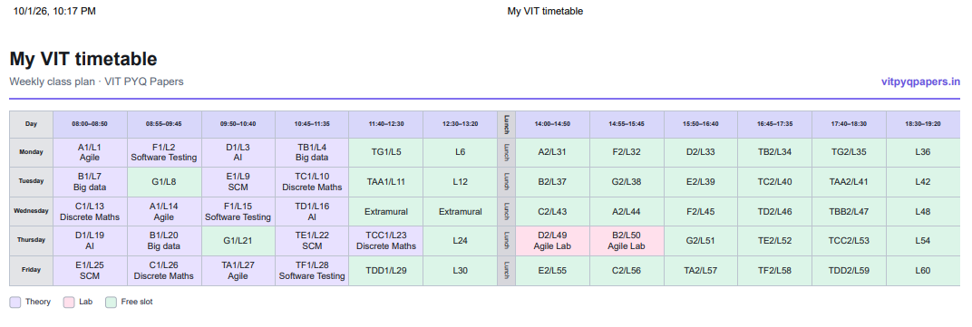
Community: chat, friends and recognition
- Global Chat: Request papers and help other students in the open community chat.
- Friends: Search users, send friend requests and message privately.
- Leaderboard: See who contributes the most uploads, ZX and downloads.
- Feedback: Share your thoughts with the developer from the homepage.

Student Feedback:  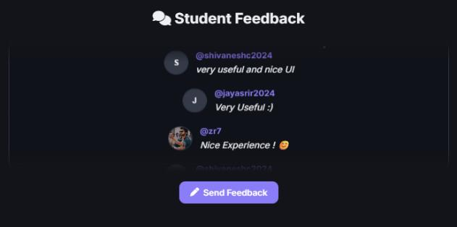  Profile & Uploading:  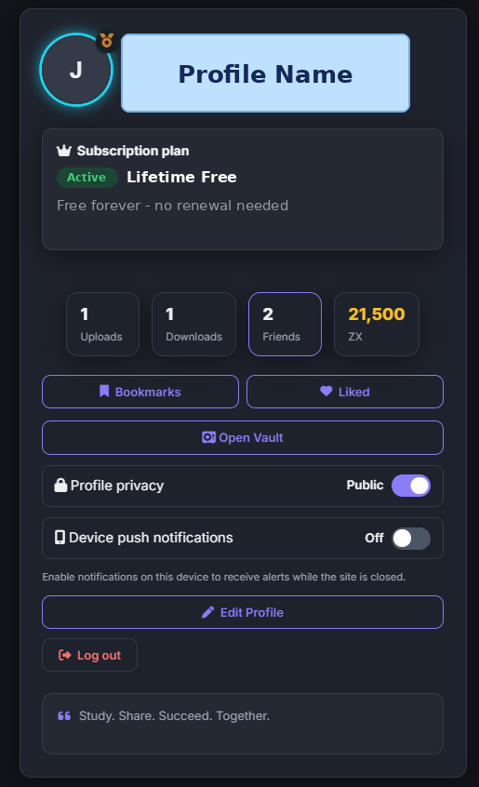  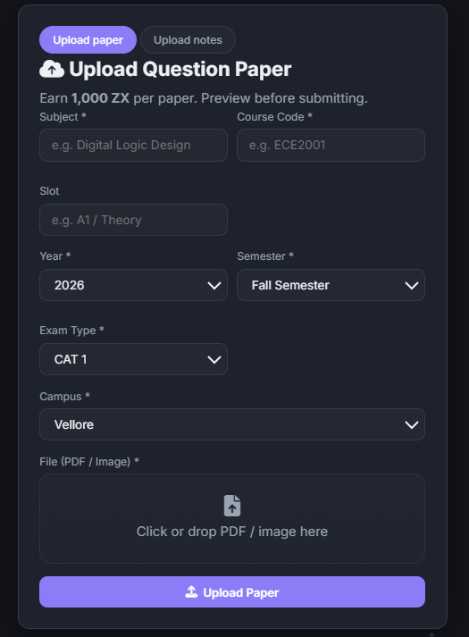 | Global Chat and Messages:  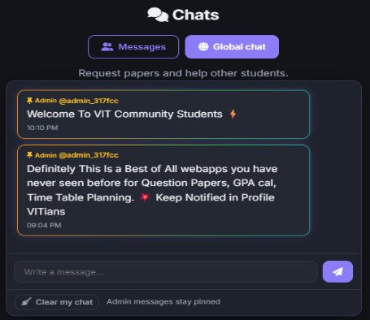  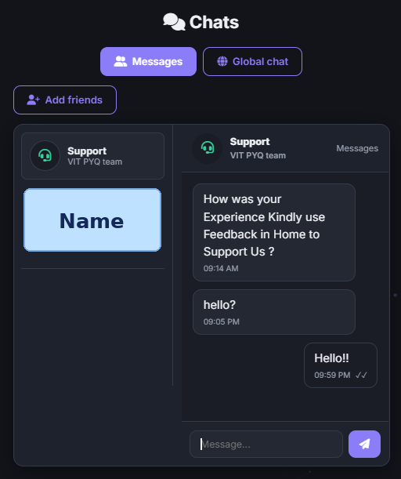  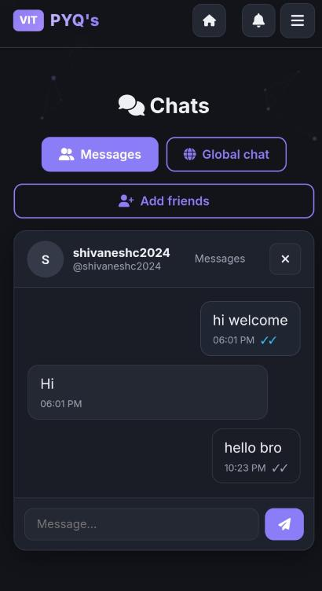

Notifications:  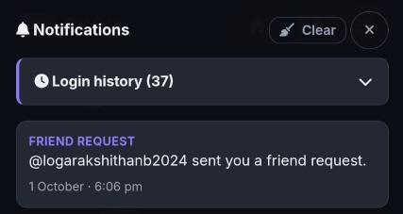 | FAQ:  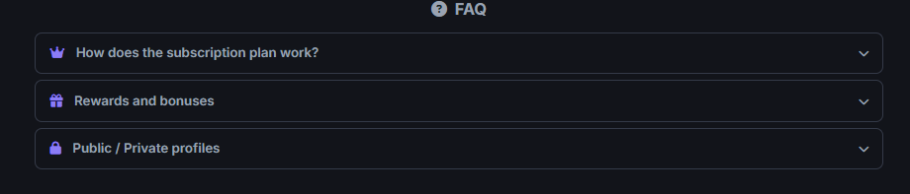

4. ZX Rewards & Store
Contribute, earn and personalise your profile

ZX is the platform's own currency. It is not real money, it is simply a fun way to thank contributors.
How to earn ZX | Reward
Join as a new user | 30,000 ZX
Upload a question paper | +1,000 ZX
Upload study notes | +2,000 ZX
Spend it in the ZX Store. Everything you buy goes into your Vault, where you can Apply or Remove it any time without buying again.
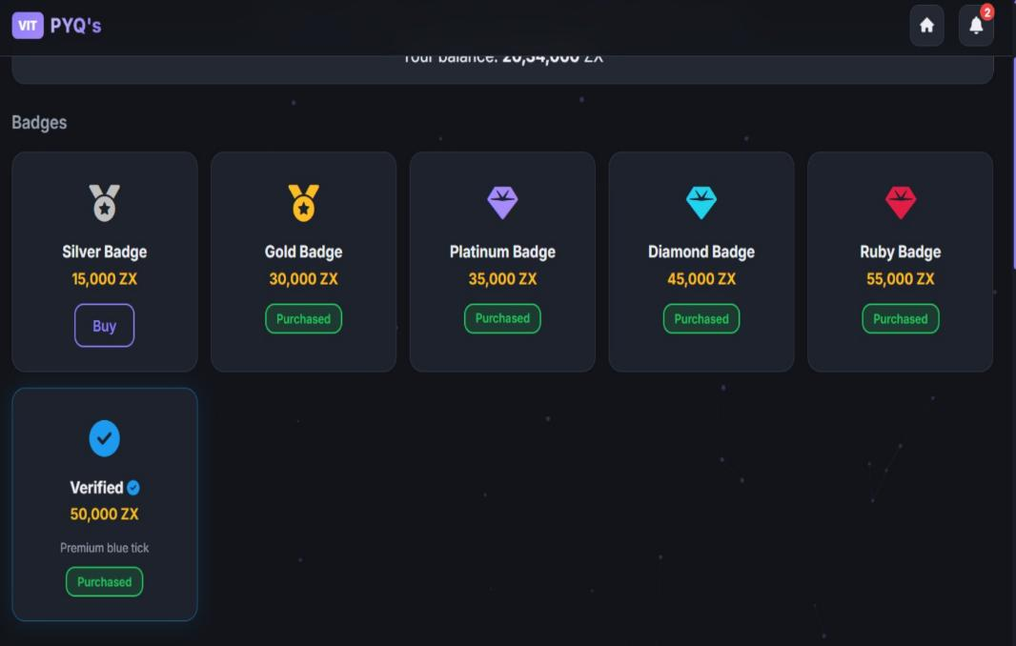 | 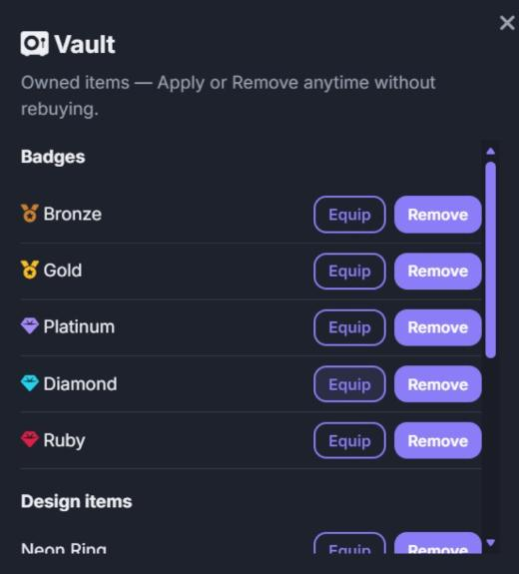

5. Subscription

- Free and lifetime: The subscription is completely free, and access is for life. There is nothing to pay and nothing to renew.
- Open to every user: Every logged-in user gets full lifetime access from the day they join.
- Stay informed: Your plan is always shown on your profile.

6. How to Use the Website
Get started in under two minutes

1 | Open the link  Visit https://vit-pyq-v2.web.app in any web browser on your phone or laptop.
2 | Log in  VIT students tap Continue with Google by choosing their campus.
3 | Accept the community terms  A quick read and a tick, so everyone uses the platform respectfully.
4 | Browse Media  Open Media to explore papers and notes using the filters.
5 | Download or upload  Tap a paper, then download. To contribute, go to Upload, fill in the details, preview and submit.
6 | Earn, spend and climb  Collect ZX, spend it in the Store and rise on the Leaderboard.

7. Privacy, Safety & Trust

- You control your profile: Choose Public or Private. A private profile shows only a lock message and a Send Friend Request button.
- Private downloads: Your download history is visible only to you and the Admin. Public profiles never show downloads.
- No ads, no tracking: Site data is used only to keep your session and preferences working. No advertising or analytics cookies, and no ads.
- Moderated community: Admins can remove inaccurate or inappropriate material and act on misuse, with a message explaining the reason.
- Community rules: Share only material you have permission to share, and never post personal or confidential information.

8. Technical Details

Hosting | Hosted on Google Firebase Hosting (web.app)
Sign-in | Google sign-in for VIT students; personal email registration for others
Built with | Standard web technologies; works in any modern browser on mobile & desktop
Exports | Excel and PDF / print for GPA results and timetables
Notifications | Optional device push notifications (off by default)
Nature of project | Independent, open-source student community
Created by | Zaheer R (Zr7), CSE student, VIT Vellore

Ready to make your semester easier?
Join the VIT PYQ's community today. It's free, it's simple and it's built by a VITian for VITians.
https://vit-pyq-v2.web.app
Share this with your friends and help every VITian!
Thank You!
Our Motto
Why this project exists

Not built to impress. Built to help every VITian.
This project is not made to impress anyone. It is not made to prove that a developer knows how to code, and it is not made to show off a passion. It exists for one reason only: to solve a real problem that every VITian faces.
Today, students search across many different websites and apps just to get their basic academic work done: one place for question papers, another for notes, another for planning a timetable, another for calculating GPA and CGPA. That scattered effort costs time, and time is what a student never has enough of.
Our aim and motto is to build the best product of its kind that exists today, shaped by the ideas of seniors and juniors alike, and polished until every feature is implemented perfectly. We want this to become a standard product that stands out against all the rest.
For a VITian, this is the one tool to plan a timetable, predict GPA and CGPA, and find PYQ papers and notes, all in one place, free and for life.
This project does not belong to its developer. It belongs to the students. It is driven by students, built for students, and powered by the people who use it.
All we ask of you is simple: become a user, follow this website, and share it with a friend. Every upload, every note and every new member makes this community stronger, and helps the next VITian walk into an exam a little more prepared.
Study. Share. Succeed. Together.
Our Domains
Use whichever link works best for you

Domain type | Link
Firebase domain | https://vit-pyq-v2.web.app
Custom domain | https://vitpyqpapers.in
Vercel domain | https://vitpyqpapers.vercel.app

Please note: VIT PYQ's is an independent student community and is not affiliated with, endorsed by or operated by VIT. Shared material is user-provided, so please verify papers and notes before academic use. Illustrations in this document are for explanation only; sample values shown are not real data.

